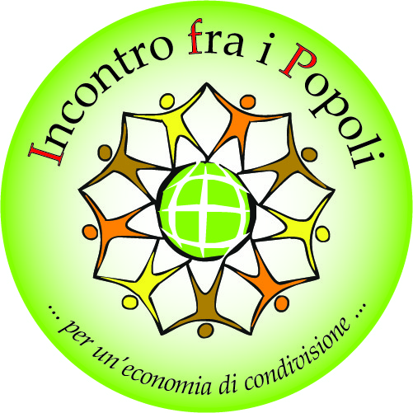**GRADUATION THESIS**

**THESIS in search of an Author**

1. **CAMEROON** Pre-colonial cultural heritage of the present autochthon populations living in Extreme North Cameroon.
2. **CAMEROON** The value of psycho-magic acts therapy associated to naturopathic autochthon therapies in the ancient Cameroon peoples.
3. **CAMEROON** Development of aggregative and cooperative trends in the Extreme North Cameroon’s rural world.
4. **TCHAD** Islamic Government and Catholic Church in Tchad: glimmers of cohabitation.
5. **D.R.CONGO** Social, cultural and environmental development in Bushi’s area thanks to 50 years’ work of *Comitè* *Anti* *Bwaki* NGO.
6. **D.R.CONGO** Non-state and socioeconomic actors in Kinshasa suburbs.
7. **D.R.CONGO** Draw up a business for 419 hectares owned Catholic University of Congo.
8. **D.R.CONGO** 20 years of psychosocial rehabilitation and educational commitment for PEDER’s street children in Bukavu.
9. **D.R.CONGO** Alternative social help and psychological rehabilitation methods devised and tried out by PEDER in Bukavu.
10. **D.R.CONGO** Agricultural, social and cultural potential in Kabinda.
11. **ITALY** Italian methodologies and strategies promoting the politic weight of CSOs developing countries.
12. **ITALY**  Different approaches to partnership concept in Italian ONG’s world.
13. **ITALY** Biogas production coming from domestic livestock, for domestic use in developing country.
14. **ITALY** Alternative energies from domestic and industrial rejects in developing country: techniques and technologies.
15. **ITALY** Ecological and social sensitiveness’ development in compulsory education involved in the *Tappa & Stappa* campaign.
16. **ROMANIA** Romanian civil society facing to new generations’ weakness.
17. **ROMANIA** Multiethnic and interreligious cohabitation in Romania.
18. **SRI LANKA** Trincomalee and Mannar NGOs’ ideas for Tamil socio-economical recovery.
19. **SRI LANKA** Tamil’s psycho-social evolution in North Sri-Lanka from the LTTE period until the post-massacre 2008-2009.
20. **TOGO** Civil society, agriculture, livestock and trustworthy tourism in Sokodé.